Student Name: wenshuo Pan

Student ID: 1226506

Username: WENSHUOP

Section 2:

Mean:

-d: Do not resolve addresses to hostnames.

-w: Wait timeout milliseconds for each reply.

1 one millisecond

Importance:

-d:  This can speed up tracert performance.

-w: 1 Set the amount of time (in one millisecond) to wait for each reply

But here I used 1000ms means wait 1s for each reply.

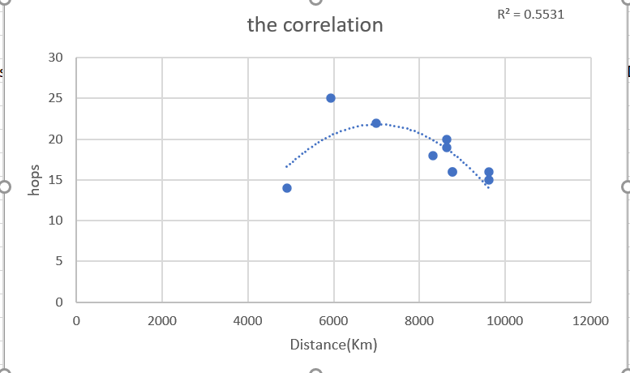

2.1

According to the graph 2.1, I thought there is no correlation between geographical distance and the hops times. Square R is less 1.

The network layer is concerned with getting packets from the source all the way to the destination. Getting to the destination may require making many hops at intermediate routers along the way. The major components of the network are the ISP’s equipment (routers connected by transmission lines). Different ISP has different equipment. According to the routing algorithm, not every time the hops times are same. Sometime the best route change when traffic jam occurs. So, there is no correlation.

Section 3.1:

Average delay:

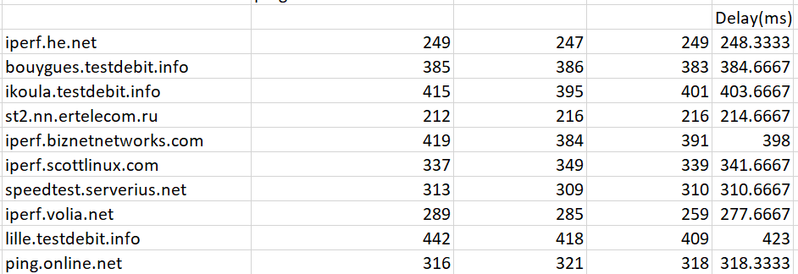

3.1.1

Average jitter:

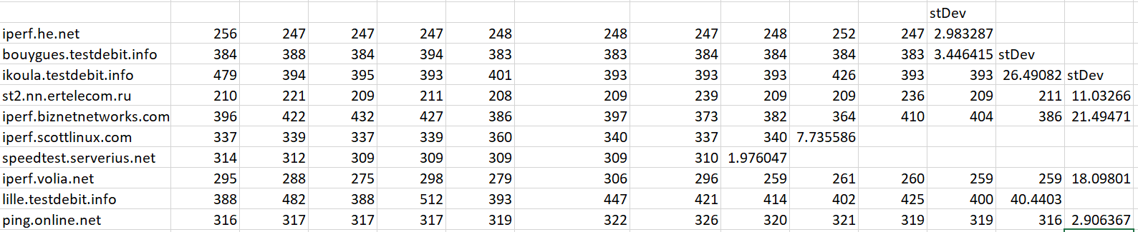

3.1.2

The average round-trip delay versus the approximate physical geographical distance to the server:

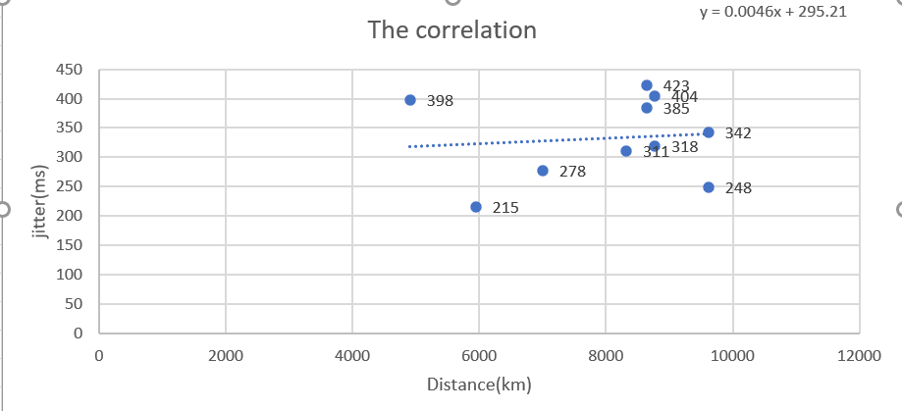

3.1.3

The jitter versus the approximate physical geographical distance to the server:

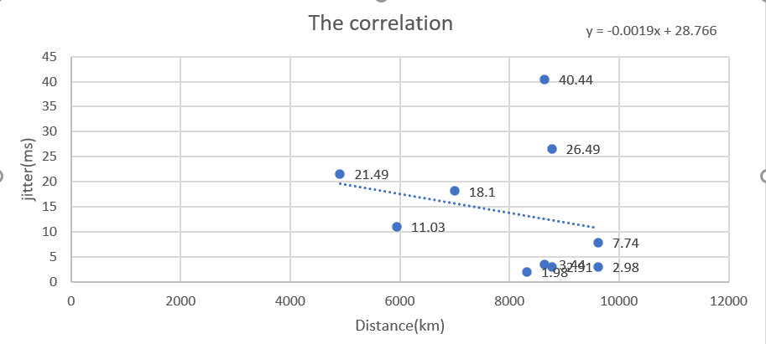

3.1.4

Section 3.2:

According to 3.1.3 and 3.1.4

The average round-trip delay has positive correlation with the approximate physical geographical distance to the server, but the jitter has negative correlation with distance.

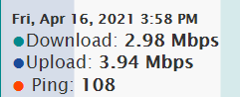

3.2.1

The download speed: 2.98 Mbps

The upload speed: 3.94 Mbps

People share the network: 3

Load on network through other apps:2

Influencing factors of delay about my networking environment are Network occupancy and network bandwidth. The network bandwidth is insufficient. If the client and server are directly connected through a router, but the maximum is only 10Kbps, but at the same time there are multiple applications that need to transmit a data volume far exceeding 200Kbps, which will cause a large amount of data loss, which will behave as a delay.

Insufficient processing bandwidth. If the client and server are directly connected through a router and the bandwidth is sufficient, but the server's processing capacity is insufficient, it will also cause delays.

Network usage is too high, it will also cause delays.

Section 3.3:

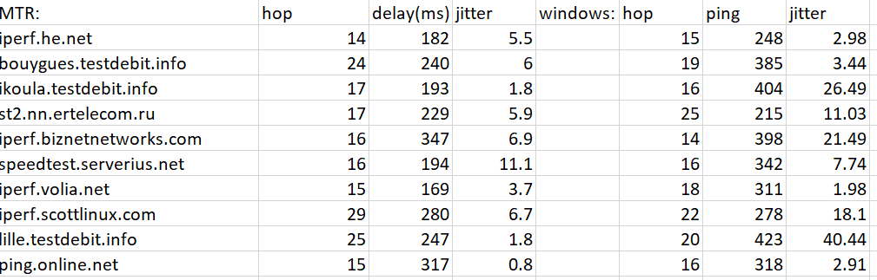

3.3.1

According to data collected from windows command prompt and from MTR in Linux. the number of hops, ping and jitter data are different. The reason is these two systems has different IP address although in one computer. So, the number of hops is different. Ping test in windows has packet loss, which worse than MTR. Packet loss will have more delay. MTR collected 10 packet data and in different systems. So, it is more accurate. The results of delay and jitter are different as well.

Section 4(iperf.he.net I use VPN test it, because that only can only be used VPN to test)

Section 4.1:

Bandwidth delay product is a measurement of how many bits can fill up a network link. It gives the maximum amount of data that can be transmitted by the sender at a given time before waiting for acknowledgment. Thus, it is the maximum amount of unacknowledged data.

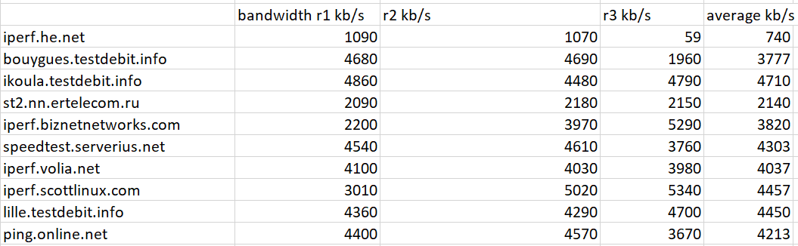

Section 4.2:

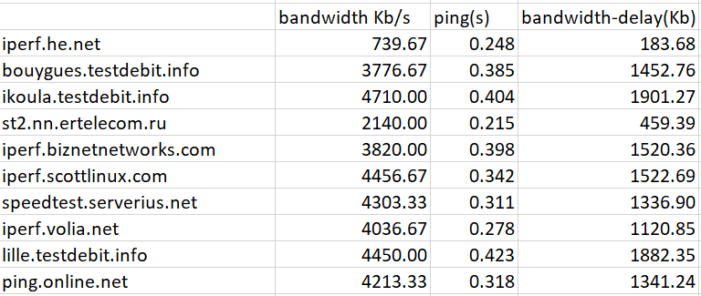

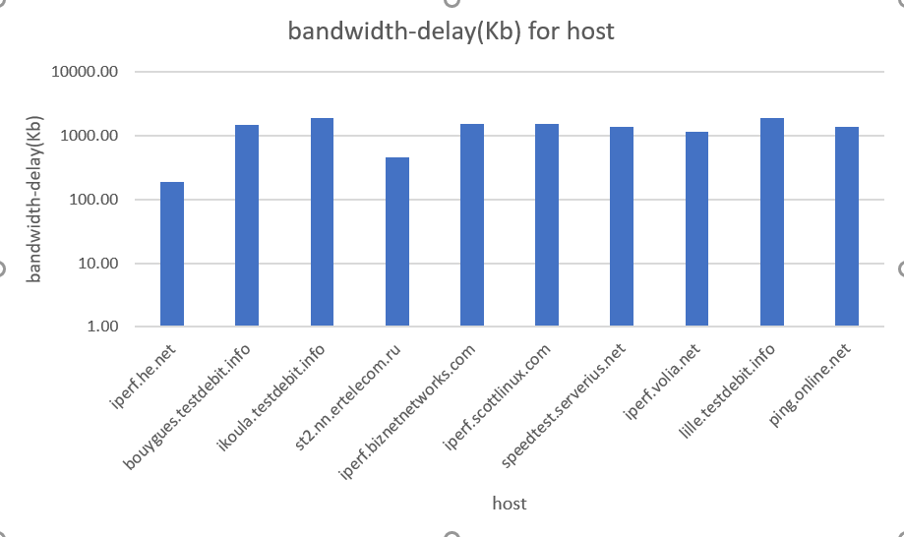

Comparative analysis: Most bandwidth-delay product of host is over 1000kb, but iperf.he.net just over 100kb.

The reason is I used VPN to test, and it cause different delay and bandwidth. My network is long-fat network, because all results of bandwidth product are over 100Kb. bandwidth-delay product is the product of data link’s speed and delay time. So, the high bandwidth product is mean high network link speed.

Network environment influence results: network occupancy is high like many software running E.g.: WeChat, Facebook and Steam. That cause delay increase and bandwidth decrease. So, the bandwidth-delay product is different.

Outliers: host: iperf.he.net

Reason: I used VPN to test. The delay time and bandwidth are different than without VPN network. So, the bandwidth-delay product is different.

Section 4.3:

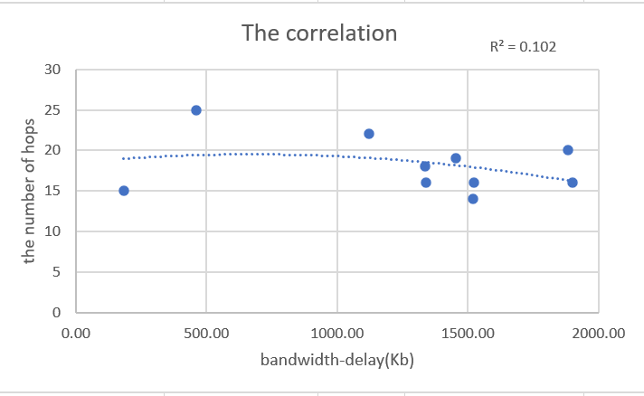

There is no correlation between hops and bandwidth-delay, because the R square is less than 1.

Section: 4.4:

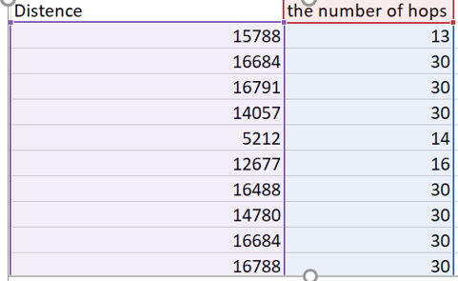

4.4.1

Use same IP address: the number hops and distance are different if I use VPN to test in 4.4.1, because the IP is change.

Close extra app: extra app will increase delay. For instance WeChat, Facebook and Steam are running when you test Ping.

Section A:

My location:

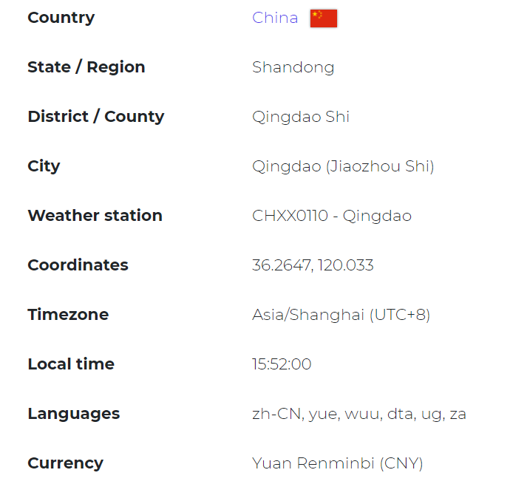

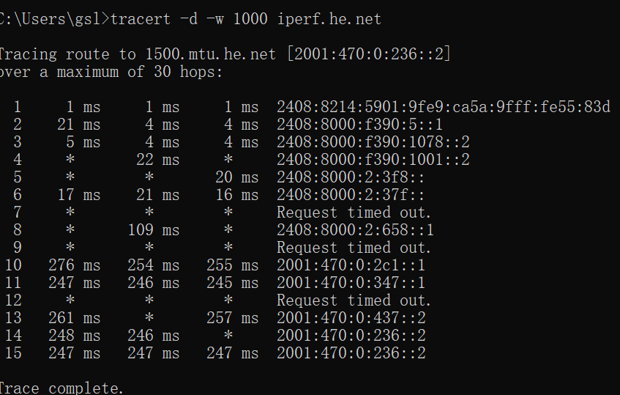 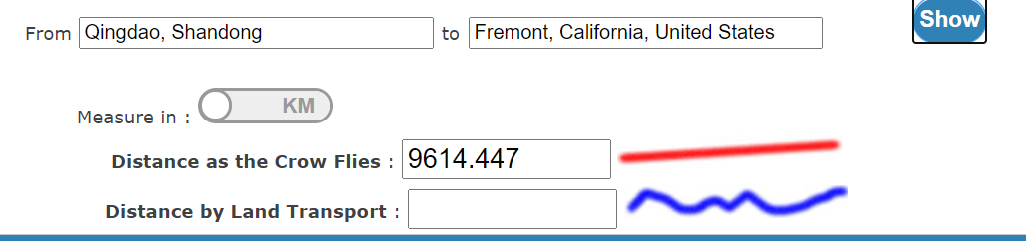

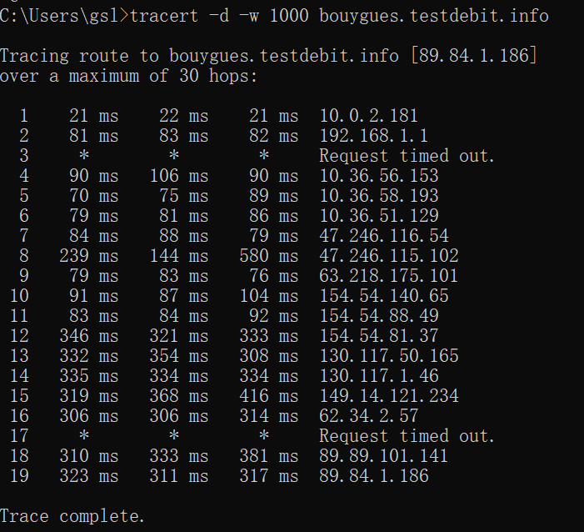 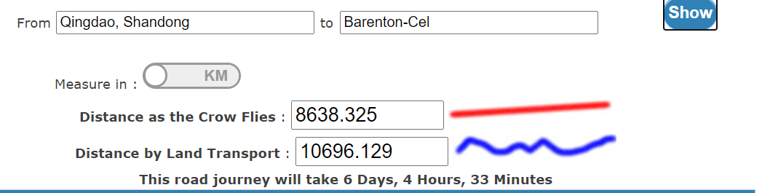

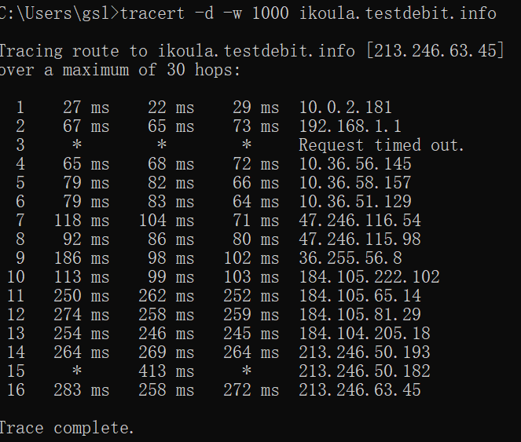 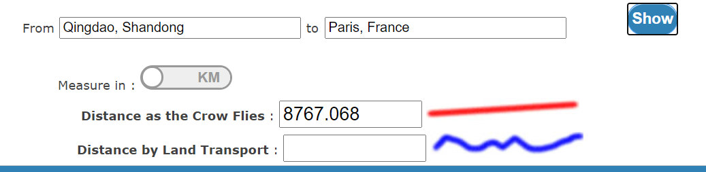

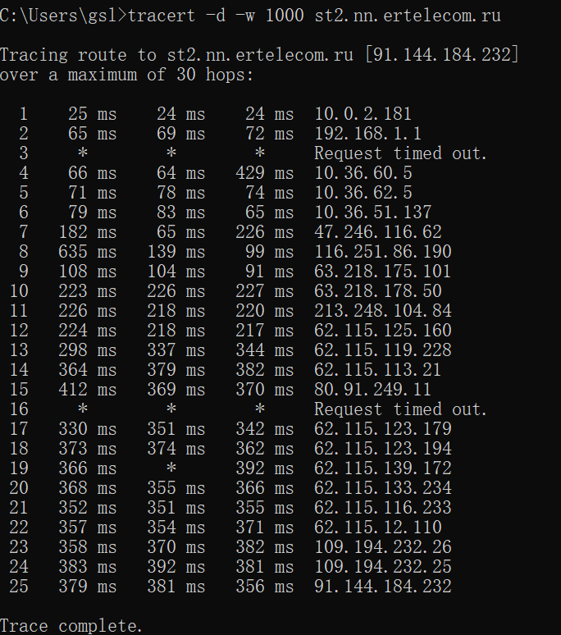 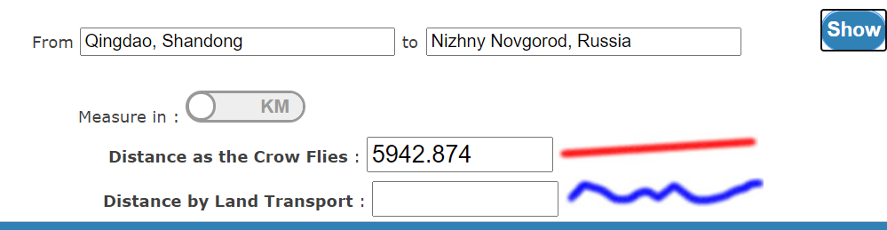

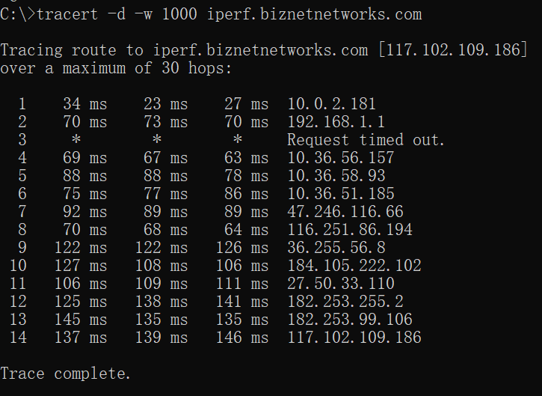 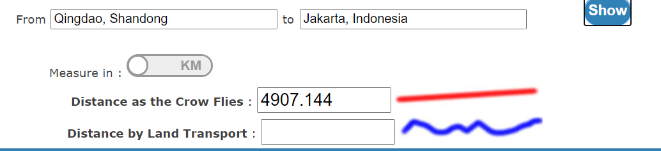

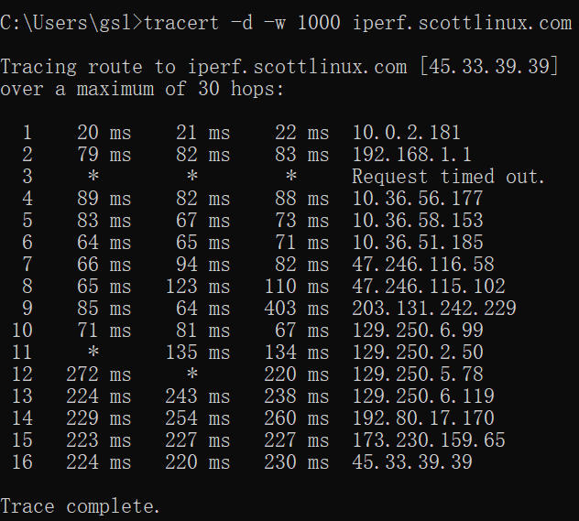

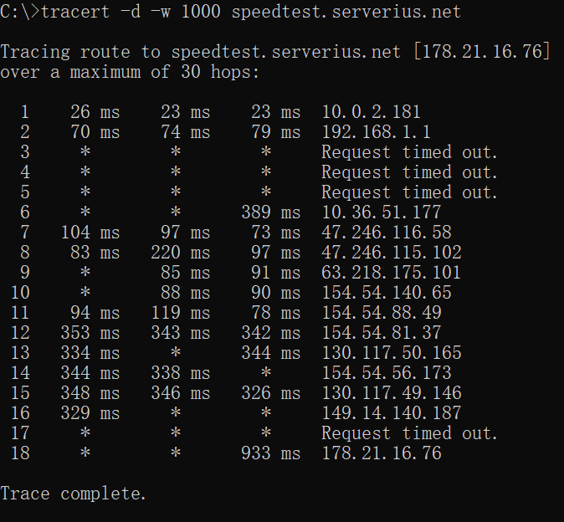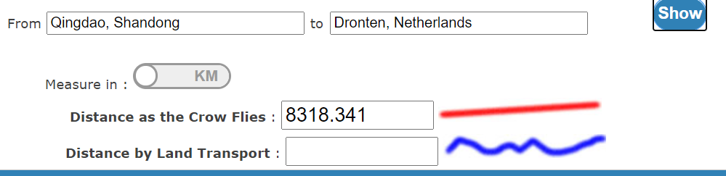

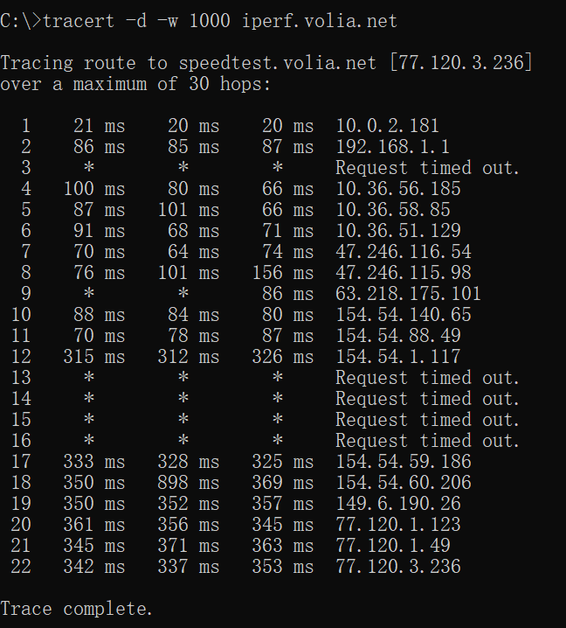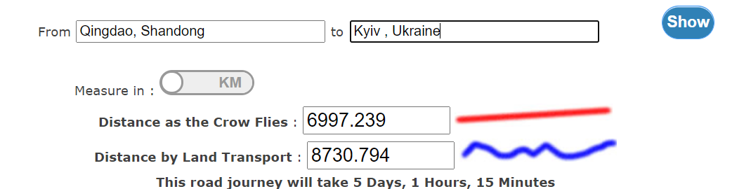

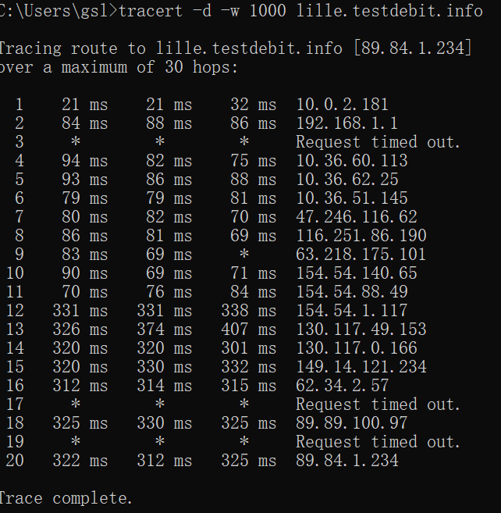

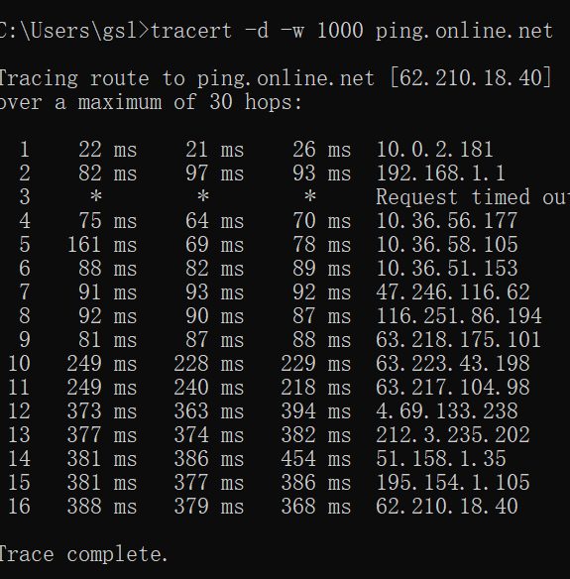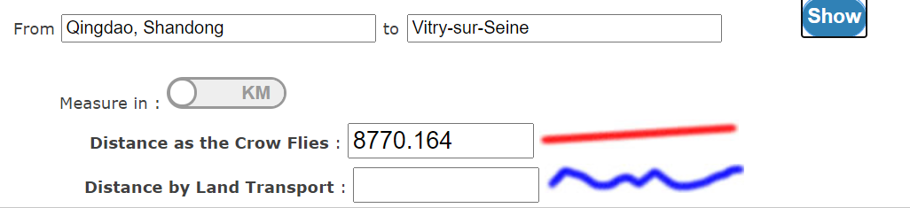

Section C:

